Roadmap

Comprehensive Rize Exchange Development Roadmap
This document covers the entire product lifecycle from market research to launch and beyond, with timelines, resource requirements, and strategic considerations.

Market Overview & Research 1
Current Cryptocurrency Derivatives Market 2
User Research & Personas 2
Product Development Timeline 3
Phase 1: Planning & Research (3 months) 3
Phase 2: Core Platform Development (6 months) 3
Phase 3: Security & Testing (3 months) 4
Phase 4: Launch & Growth (Ongoing) 4
User Flow For Trading 5
Testing Strategy 7
Security Testing (Critical for Financial Applications) 7
Performance Testing 7
Functional Testing 7
Go-To-Market Strategy 8
Pre-Launch Phase (3 months) 8
Launch Phase (1-2 months) 8
Post-Launch Growth (6-12 months) 8
Timeline of Expenditures 9
Key Performance Indicators 9
Pre-Launch KPIs 9
Launch KPIs 9
Long-term KPIs 10

Market Overview & Research

Current Cryptocurrency Derivatives Market
The cryptocurrency derivatives market has grown substantially in recent years. Platforms like Delta Exchange offer futures, options, perpetual swaps, and interest rate swaps primarily for Bitcoin, Ethereum, and other major cryptocurrencies.
Key market players include:
- Binance Futures
- BitMEX
- FTX (now defunct but historically significant)
- Deribit
- OKX
- Bybit
- Delta Exchange

User Research & Personas
Based on cryptocurrency derivatives users, we can identify several key personas:
1. Professional Trader (Alex)
- 30-45 years old
- Full-time trader with traditional finance background
- Trades large volumes ($50K-$500K+)
- Needs: Advanced charting, API access, high leverage, tight spreads, deep order books
- Pain points: Latency, downtime, limited instrument variety
2. Crypto Enthusiast (Maya)
- 25-35 years old
- Tech-savvy early crypto adopter
- Trades medium volumes ($5K-$50K)
- Needs: Mobile access, variety of altcoin derivatives, educational resources
- Pain points: Complex interfaces, KYC requirements, security concerns
3. Institutional Client (Quantum Capital)
- Professional trading firm or fund
- Requires institutional-grade infrastructure
- Trades very large volumes ($1M+)
- Needs: Advanced risk management, OTC desk, account management, API connectivity
- Pain points: Liquidity, counterparty risk, compliance requirements
4. Retail Novice (Jordan)
- 18-30 years old
- New to trading, moderate crypto knowledge
- Trades small volumes ($500-$5K)
- Needs: Simple UI, educational content, low fees, small minimum trade sizes
- Pain points: Complex derivatives concepts, fear of liquidation, platform complexity

Product Development Timeline

Phase 1: Planning & Research (3 months)
Month 1: Market Research & Requirements Gathering
- Conduct competitor analysis (4 weeks)
- Define product vision and strategy (2 weeks)
- Create initial product requirements document (2 weeks)
Month 2: Design System Architecture
- Design trading engine architecture (3 weeks)
- Create database schema (2 weeks)
- Design API specifications (3 weeks)
Month 3: User Experience Design
- Create user flows and wireframes (3 weeks)
- Develop UI/UX design system (3 weeks)
- User testing of wireframes and prototypes (2 weeks)

Phase 2: Core Platform Development (6 months)
Months 4-5: Trading Engine Development
- Develop matching engine (4 weeks)
- Implement order book management (3 weeks)
- Build risk management system (3 weeks)
- Create liquidation engine (2 weeks)
Months 6-7: User Interface Development
- Develop front-end application framework (3 weeks)
- Build trading interface (4 weeks)
- Implement charts and analysis tools (3 weeks)
- Create account management features (2 weeks)
Months 8-9: API & Integration Development
- Develop REST API (3 weeks)
- Implement WebSocket for real-time data (3 weeks)
- Build third-party integrations (KYC, payment processors) (4 weeks)
- Develop admin dashboard (2 weeks)

Phase 3: Security & Testing (3 months)
Month 10: Security Implementation
- Implement wallet security (3 weeks)
- Develop multi-factor authentication (2 weeks)
- Create anti-fraud systems (3 weeks)
Month 11: Quality Assurance & Testing
- Perform functional testing (2 weeks)
- Conduct load testing (2 weeks)
- Execute security audits (3 weeks)
- Perform penetration testing (3 weeks)
Month 12: Beta Testing
- Limited user beta testing (3 weeks)
- Bug fixing and platform optimization (3 weeks)
- Final security review (2 weeks)

Phase 4: Launch & Growth (Ongoing)
Month 13: Launch Preparation
- Final system checks (1 week)
- Marketing campaign execution (4 weeks)
- Customer support training (2 weeks)
Month 14: Market Launch
- Phased public launch (2 weeks)
- Initial market making and liquidity provision (4 weeks)
- User onboarding and education (ongoing)
Months 15-18: Platform Expansion
- Add additional trading pairs (ongoing)
- Implement advanced derivatives products (3 months)
- Mobile app development (3 months)

User Flow For Trading
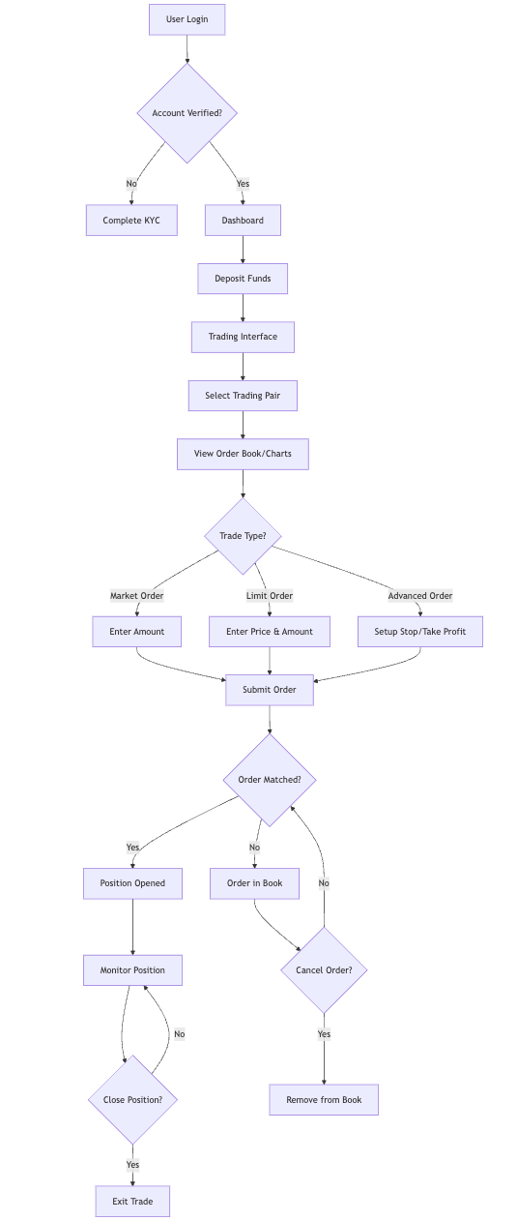

Testing Strategy

Security Testing (Critical for Financial Applications)
- Penetration Testing
  - Duration: 3-4 weeks
  - Team: External security firm + 1 internal Security Engineer
  - Focus areas: API vulnerabilities, authentication flaws, injection attacks
- Smart Contract Audits (if applicable)
  - Duration: 2-3 weeks
  - Team: Specialized blockchain security firm
  - Focus areas: Logic bugs, reentrancy attacks, access control issues
- Disaster Recovery Testing
  - Duration: 2 weeks
  - Team: DevOps + Security team
  - Focus areas: Data recovery, system failover, backup integrity

Performance Testing
- Load Testing
  - Duration: 2-3 weeks
  - Team: 2 QA Engineers, 1 DevOps Engineer
  - Focus areas: Order processing under load, market data distribution, WebSocket connections
- Stress Testing
  - Duration: 2 weeks
  - Team: 2 QA Engineers, 1 Backend Engineer
  - Focus areas: System behavior during market volatility, peak user activity

Functional Testing
- Trading Engine Testing
  - Duration: 4-6 weeks (continuous)
  - Team: 2-3 QA Engineers, 1 Trading Specialist
  - Focus areas: Order matching, position management, liquidation accuracy
- User Acceptance Testing
  - Duration: 3-4 weeks
  - Team: Product Manager, select beta users
  - Focus areas: Real-world use cases, UI/UX issues, trading workflows

Go-To-Market Strategy

Pre-Launch Phase (3 months)
- Community Building
  - Create social media presence (Telegram, Discord, Twitter)
  - Develop educational content about derivatives trading
  - Host AMAs and webinars about platform features
- Partnership Development
  - Secure market makers for initial liquidity
  - Partner with analytics platforms
  - Establish relationships with crypto media outlets
- Alpha/Beta Testing
  - Invite-only alpha testing with power users
  - Collect feedback and iterate
  - Open beta with limited features

Launch Phase (1-2 months)
- Phased Launch
  - Start with limited trading pairs
  - Gradually increase leverage limits
  - Roll out advanced features as platform stabilizes
- Acquisition Campaigns
  - Trading competitions
  - Fee discounts for early users
  - Referral program implementation
- Liquidity Building
  - Market maker incentives
  - Volume-based rebates
  - Strategic token listings (if applicable)

Post-Launch Growth (6-12 months)
- Feature Expansion
  - Mobile application release
  - Additional derivatives products
  - Advanced trading tools
- Market Expansion
  - Target new geographic regions
  - Secure additional regulatory approvals
  - Develop institutional client offerings
- Ecosystem Integration
  - Third-party trading tool integrations
  - API partner program
  - Data feed partnerships

Timeline of Expenditures
Phase 1 (Planning & Research): 15% of total budget Phase 2 (Development): 40% of total budget Phase 3 (Testing & Security): 20% of total budget Phase 4 (Launch & Initial Growth): 25% of total budget

Key Performance Indicators

Pre-Launch KPIs
- Development milestones met on time
- QA test coverage percentage
- Security audit clearance
- Beta tester satisfaction metrics

Launch KPIs
- User registration growth rate
- Deposit conversion rate
- Trading volume by instrument
- User retention rates
- Platform uptime percentage
- API usage metrics

Long-term KPIs
- Monthly active users
- Average trading volume per user
- Fee revenue growth
- Market share percentage
- Customer acquisition cost
- Lifetime value of users

